FRONT END FULL STACK 201 - 202 -205 -206 IFMOTICA FES

***REACT TP 05* composants fonction et class props et state**

**Créer le composant class Client.js suivant**

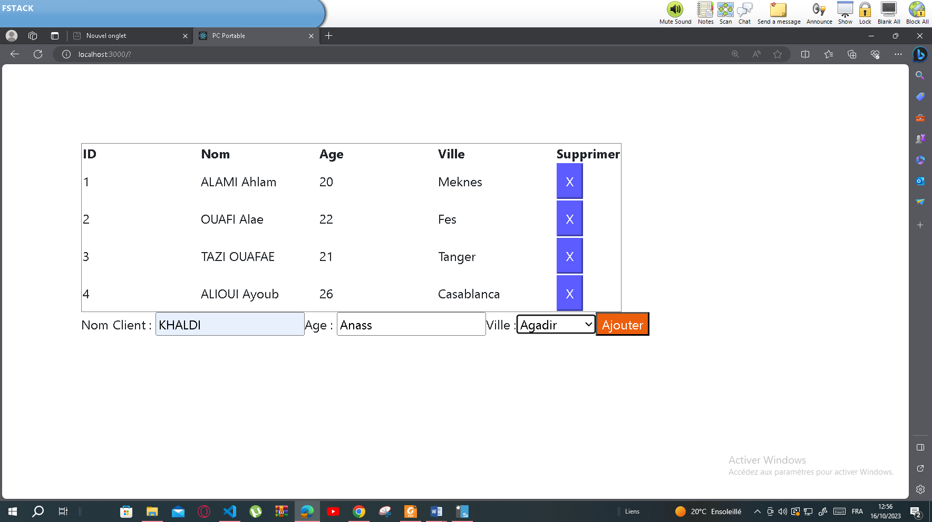

**Client.js**

import React from "react";

export default class Client  extends React.Component{

 state={TClient:[{id:1,Nom:"ALAMI Ahlam",Age:20,Ville:"Meknes"},{id:2,Nom:"OUAFI Alae",Age:22,Ville:"Fes"},{id:3,Nom:"TAZI OUAFAE",Age:21,Ville:"Tanger"},

 {id:4,Nom:"ALIOUI Ayoub",Age:26,Ville:"Casablanca"}],id:5,NomAj:"",AgeAj:"",VilleAj:""}

 supprimer=(idsup)=>{

*this*.setState({TClient:[...*this*.state.TClient.filter((cli)=>{return cli.id!==idsup })]})

 }

 ajouter=(e)=>{

e.preventDefault();

    const T=[...*this*.state.TClient];

    T.push({id:*this*.state.id,Nom:*this*.state.NomAj,Age:*this*.state.AgeAj,Ville:*this*.state.VilleAj})

*this*.setState({id:*this*.state.id+1,NomAj:"",AgeAj:"",VilleAj:""})

*this*.setState({TClient:T})

 }

 render(){

    return <>

    <form onSubmit={*this*.ajouter} style={{margin:"100px"}}>

    <table border="1"  >

        <tr><th>ID</th><th>Nom</th><th>Age</th><th>Ville</th><th>Supprimer</th></tr>

        { *this*.state.TClient.map((cli)=>{ return <tr key={cli.id}><td width="150px" >{cli.id} </td><td width="150px" >{cli.Nom} </td><td width="150px" >{cli.Age} </td><td width="150px" >{cli.Ville} </td><td><button style={{color:"#fff", borderColor:"#5C5CFF",

padding:"10px", backgroundColor:"#5C5CFF" }} onClick={()=>{*this*.supprimer(cli.id)}}>X</button></td></tr>})}

    </table>

    Nom Client : <input type="text" id="idtn" value={*this*.state.NomAj} onChange={(e)=>{*this*.setState({NomAj:document.getElementById("idtn").value})}} ></input>

    Age        : <input type="text" id="idta" value={*this*.state.AgeAj} onChange={(e)=>{*this*.setState({AgeAj:document.getElementById("idta").value})}} ></input>

    Ville      :<select id="idtv" onChange={(e)=>{*this*.setState({VilleAj:document.getElementById("idtv").value})}} >

        <option>Fes</option>

        <option>Tanger</option>

        <option>Casablanca</option>

        <option>Meknes</option>

        <option>Agadir</option>

    </select>

    <input type="submit" className="buttonStyle" value="Ajouter"/>

    </form>

    </>

 }

}

**Index.js**

import React from 'react';

import ReactDOM from 'react-dom/client';

import './index.css';

import Client from './Client';

const root1 = ReactDOM.createRoot(document.getElementById('root'));

root1.render(<Client></Client>)

*// If you want to start measuring performance in your app, pass a function*

*// to log results (for example: reportWebVitals(console.log))*

*// or send to an analytics endpoint. Learn more: https://bit.ly/CRA-vitals*

**Index.css**

body {

  margin: 0;

  font-family: *-apple-system*, BlinkMacSystemFont, 'Segoe UI', 'Roboto', 'Oxygen',

    'Ubuntu', 'Cantarell', 'Fira Sans', 'Droid Sans', 'Helvetica Neue',

*sans-serif*;

  -webkit-font-smoothing: *antialiased*;

  -moz-osx-font-smoothing: *grayscale*;

}

code {

  font-family: source-code-pro, Menlo, Monaco, Consolas, 'Courier New',

*monospace*;

}

.buttonStyle {

  color: #fff;

  background-color:#ec5f0d;

  }